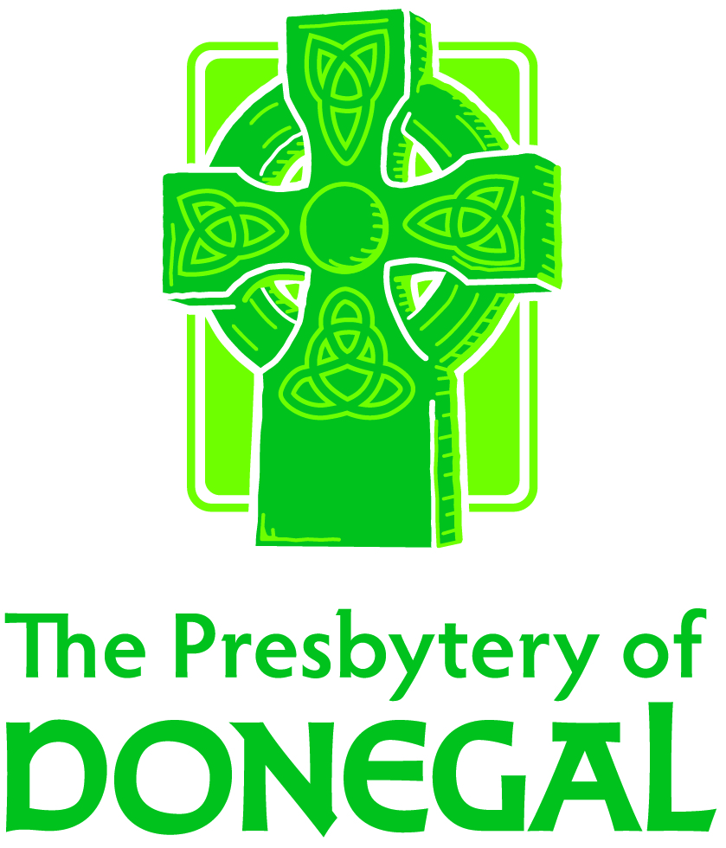
Engaging Our Mission (EOM)

Scholarship Application for Individuals

Donegal Presbytery is committed to aiding those who seek to further their discipleship, deepen their missional impact, and cultivate their competency as leaders. As such, EOM provides support to individuals seeking training, certification, education, and field experiences to deepen their impact as Kingdom leaders. The following application is designed to aid EOM in learning about and supporting your vision.

Name:______________________________ Congregation:____________________________________
Email: ______________________________ Phone: __________________________________________
Amount of Scholarship Request: $______________

- Provide the name and a brief description of the event for which you are requesting a scholarship.

- Why does this event interest you and what benefits do you anticipate (for yourself, your congregation, your community, Donegal presbytery, etc.) through participation?

- How do you wish to share your learning from this event in the context of your congregation and/or the presbytery?

- Does this event involve international travel? ______ Yes ______ No

- If this is a mission experience, are you able to attend an upcoming presbytery meeting so that we might publicly pray for you? ______ Yes ______ No

- Is this event sponsored by an agency of the PC(USA)? ______ Yes ______ No (This information helps us to determine other potential sources of funding for your event).

- Please detail all projected income sources and expenses for this event.

Request for Funds:
I/we are requesting $________________________________ from the EOM Budget to be used for _____________________________________________________to be distributed according to the following time-line:

Signature: ___________________________________________________________________________

